ANKITA DAS UG/02/BTCSECSF/2023/017
UDB LAB 7
Data:
{ roll: 1, name: "Anu", age: 22, department: "IT", marks: 85 },
{ roll: 2, name: "Riya", age: 21, department: "CSE", marks: 78 },
{ roll: 3, name: "Aman", age: 23, department: "IT", marks: 92 },
{ roll: 4, name: "Neha", age: 20, department: "ECE", marks: 74 },
{ roll: 5, name: "Raj", age: 24, department: "CSE", marks: 88 },
{ roll: 6, name: "Simran", age: 22, department: "IT", marks: 81 },
{ roll: 7, name: "Karan", age: 21, department: "ECE", marks: 69 },
{ roll: 8, name: "Priya", age: 23, department: "CSE", marks: 95 }.

db.student_UG_02_BTCSEAIML_2023_063.insertMany([
{ roll: 1, name: "Anu", age: 22, department: "IT", marks: 85 },
{ roll: 2, name: "Riya", age: 21, department: "CSE", marks: 78 },
{ roll: 3, name: "Aman", age: 23, department: "IT", marks: 92 },
{ roll: 4, name: "Neha", age: 20, department: "ECE", marks: 74 },
{ roll: 5, name: "Raj", age: 24, department: "CSE", marks: 88 },
{ roll: 6, name: "Simran", age: 22, department: "IT", marks: 81 },
{ roll: 7, name: "Karan", age: 21, department: "ECE", marks: 69 },
{ roll: 8, name: "Priya", age: 23, department: "CSE", marks: 95 }
])
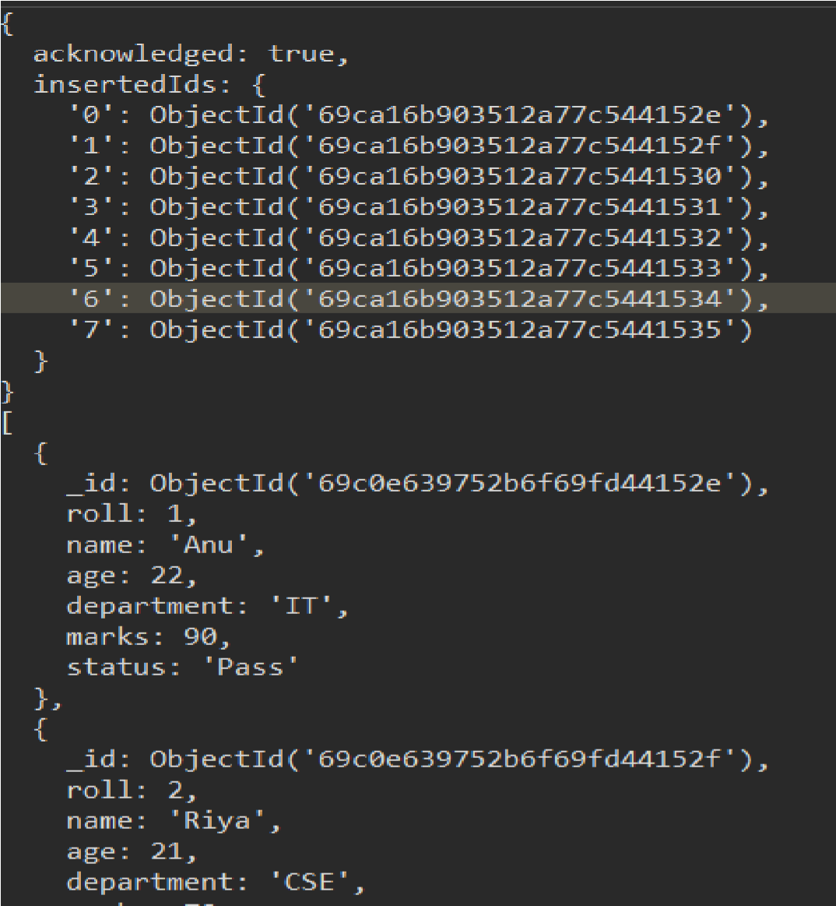
Q1. Display all documents. db.student_UG_02_BTCSECSF017.find()
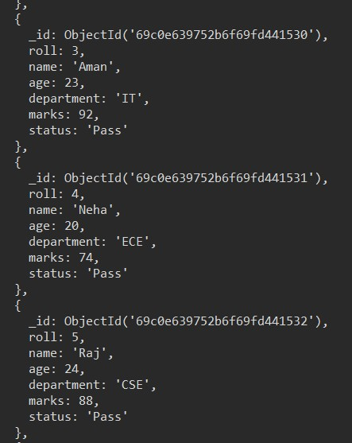
Q2. Find students from IT department db.student_UG_02_BTCSE_ CSF017.find({ department: "IT" })
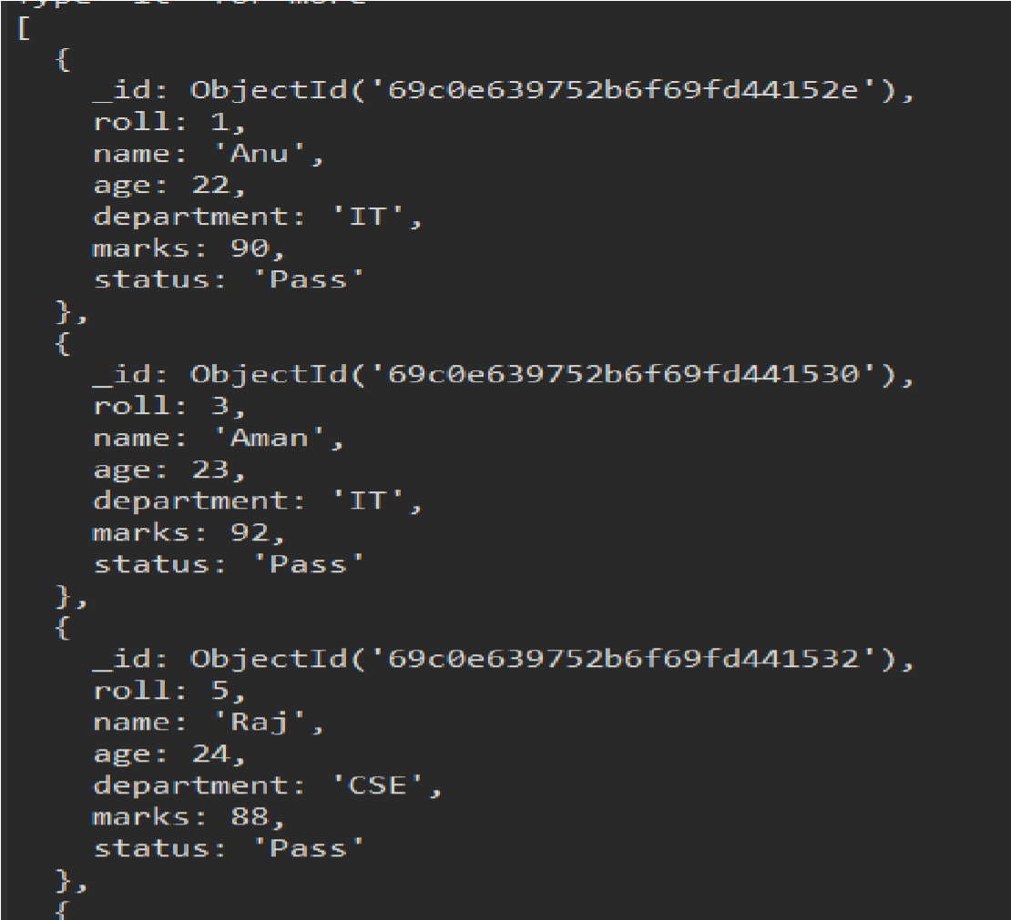
Q3. Find students with marks > 80
db.student_UG_02_BTCSE _CSF017.find({ marks: { $gt: 80 } })
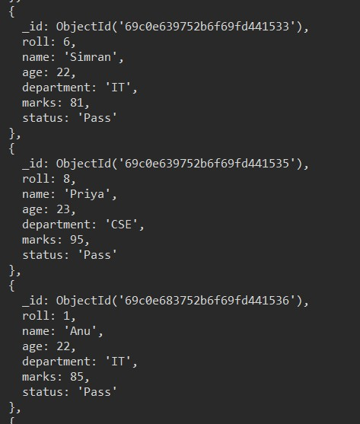
Q4. Insert one new student db.student_UG_02_BTCSE_ CSF017_063.insertOne(
{ roll: 9, name: "Rahul", age: 22, department: "IT", marks: 83 }
)
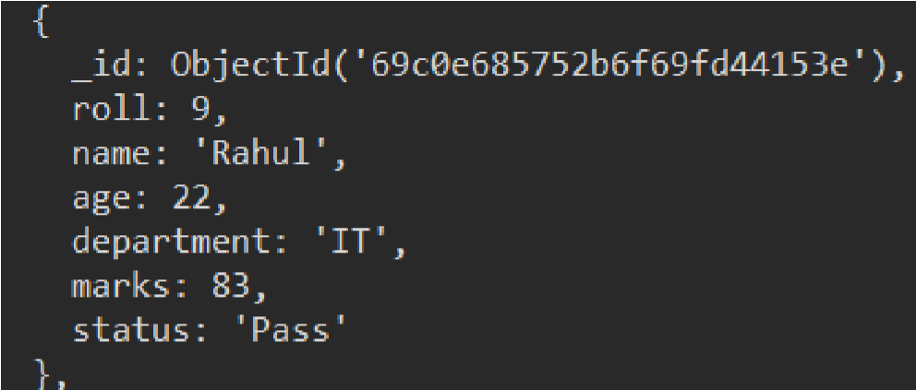
Q5. Update marks of Anu to 90.
db.student_UG_02_BTCSE_ CSF017.updateOne(
{ name: "Anu" },
{ $set: { marks: 90 } }
)
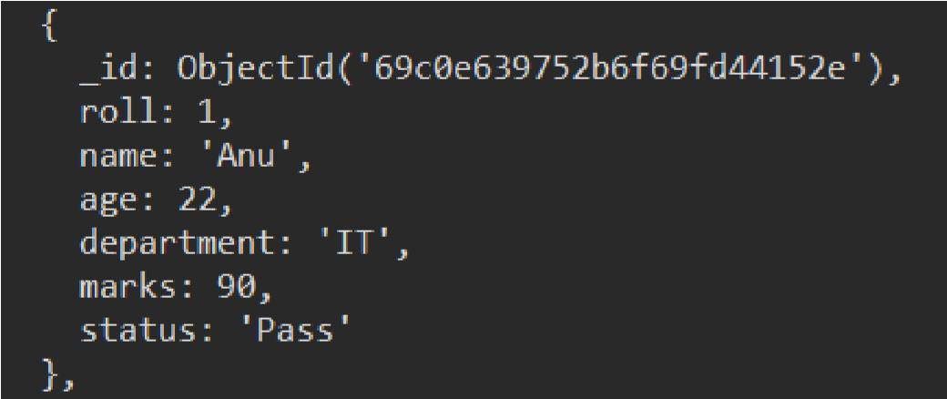
Q6. Add a new field "status: Pass" for all students db.student_UG_02_BTCSE _CSF017.updateMany(
{},
{ $set: { status: "Pass" } }
)
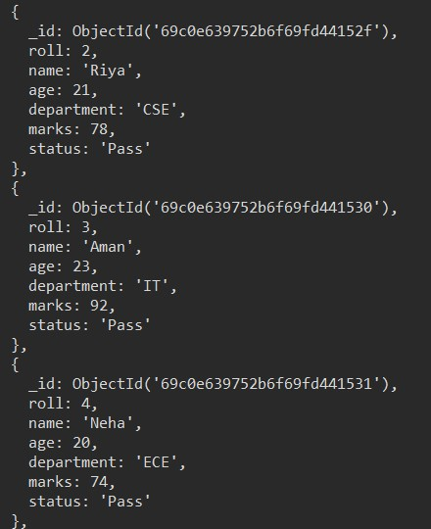
Q7. Delete all students with marks < 70
db.student_UG_02_BTCSE_CSF017.deleteMany(
{ marks: { $lt: 70 } }
)
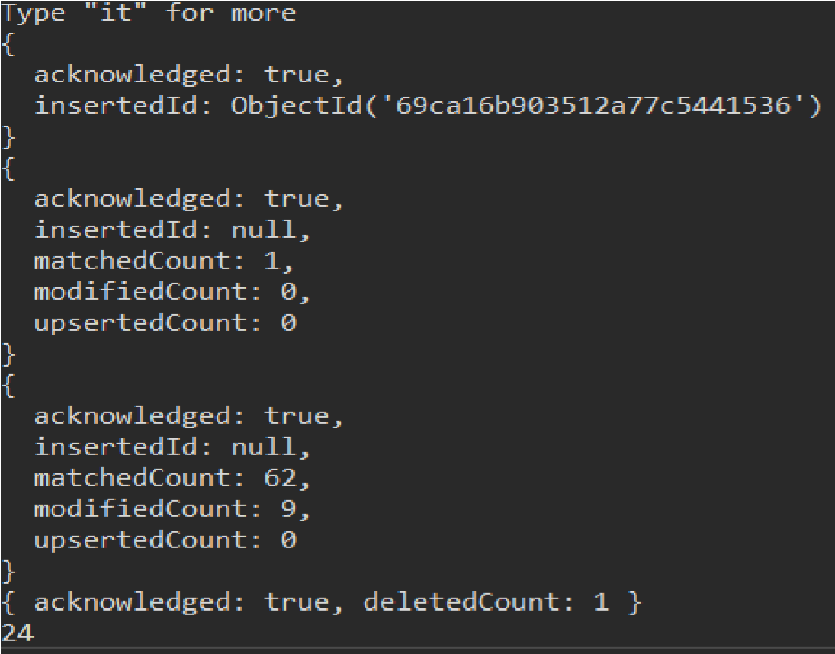
Q8. Count students in CSE department db.student_UG_02_BTCSE_ CSF017.countDocuments(
{ department: "CSE" }
)
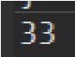
Q9. Find total students in each department db.student_UG_02_BTCSE_CSF017.aggregate([
{ $group: { _id: "$department", total: { $sum: 1 } } }
])
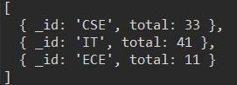
Q10. Find highest marks db.student_UG_02_BTCSE_CSF017.find()
.sort({ marks: -1 })
.limit(1)
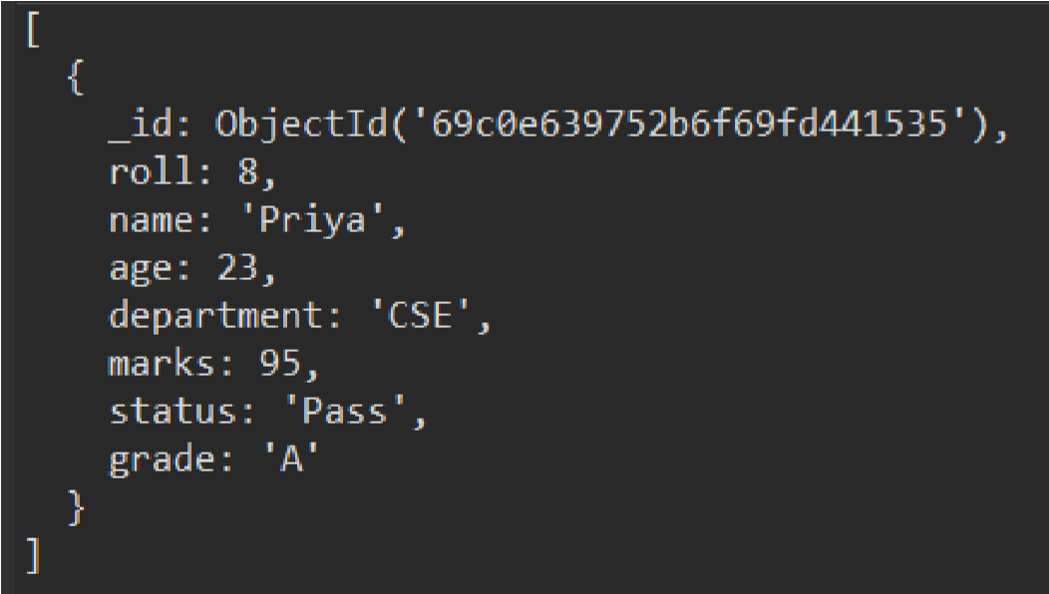
Q11. Find the second highest marks. db.student_UG_02_CSE _CSF017.find()
.sort({ marks: -1 })
.skip(1)
.limit(1)
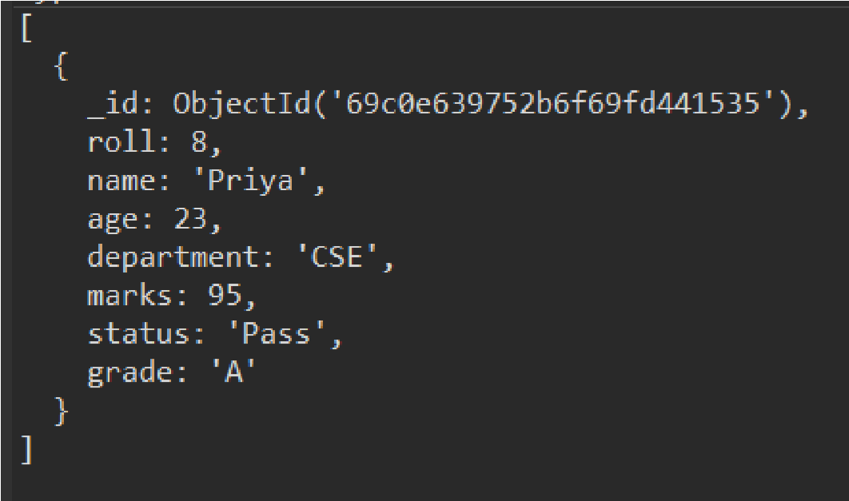
Q12. Find students whose name starts with 'A' and marks > 80 db.student_UG_02_BTCSE_ CSF017.find({
name: { $regex: "^A" }, marks: { $gt: 80 }
})
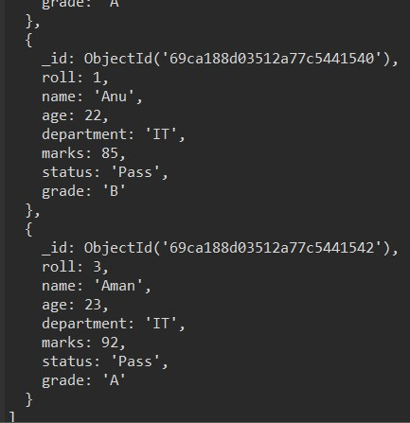
Q13. Display department-wise average marks, only for departments where avg > 80 db.student_UG_02_BTCSE _CSF017.aggregate([
{ $group: { _id: "$department", avgMarks: { $avg: "$marks" } } },
{ $match: { avgMarks: { $gt: 80 } } }
])
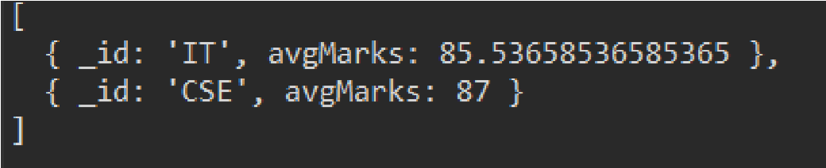
Q14. Find students with marks between 75 and 90, sorted by marks ascending db.student_UG_02_BTCSE _CSF017.find(
{ marks: { $gte: 75, $lte: 90 } }
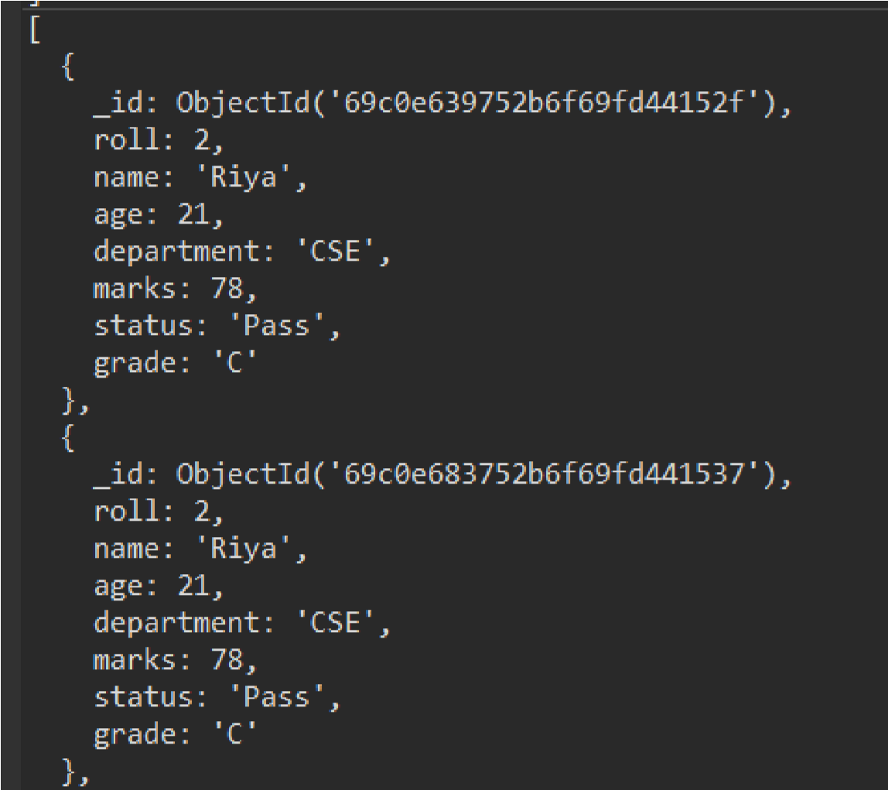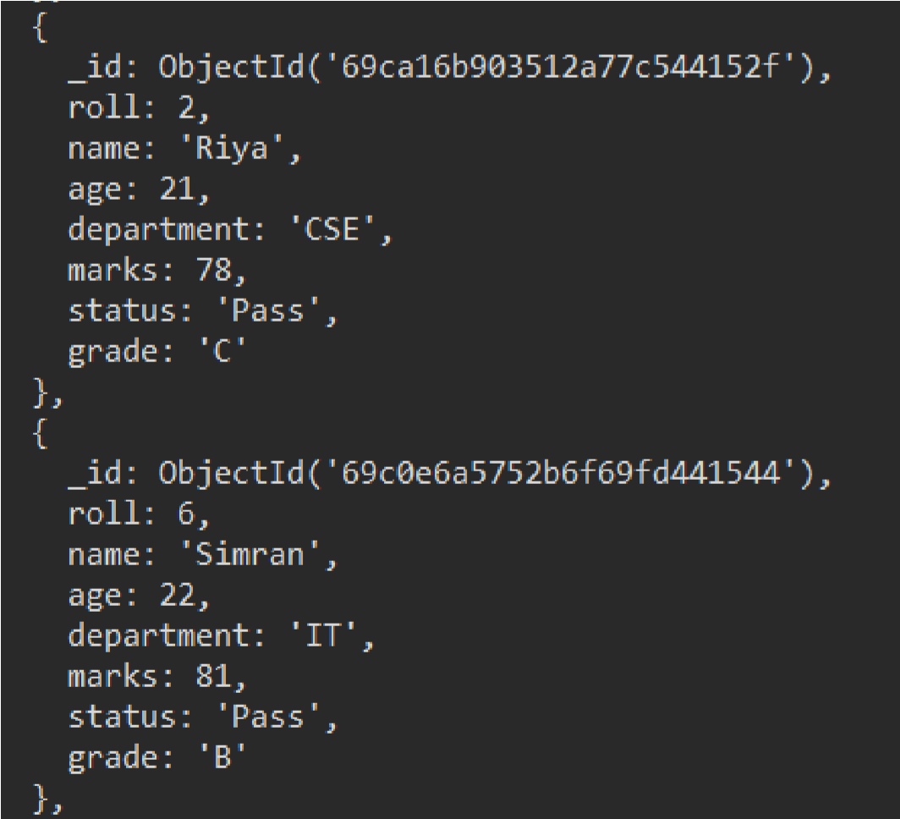
)
.
sort
(
{

marks
:

1

}
)

Q15. Add grade field based on marks

db.student_UG_02_BTCSE _CSF017.updateMany(
{},
[
{ $set: { grade: { $switch: { branches: [
{ case: { $gte: ["$marks", 90] }, then: "A" }, { case: { $gte: ["$marks", 80] }, then: "B" },
{ case: { $gte: ["$marks", 70] }, then: "C" }
],
default: "D"
}
}
}
} ]
)
